3.72: The initial y-component of the velocity is 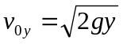, and the time the pebble is in flight is 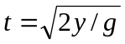. The initial x-component is 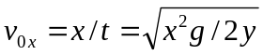. The magnitude of the initial velocity is then
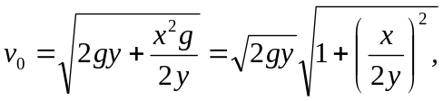
and the angle is 

